National University of Computer and Emerging Sciences, Karachi
Fall-2025, FAST School of Computing
Quiz 3
Course Code: AI2002 | Course Name: Machine learning
Instructor Name: | Date: 2nd December, 2026
Student Roll No: | Section:
Total marks: 40 | Obtained marks:

Q1. Provide the appropriate answer to the given statements.
- The vanishing gradient problem occurs when ________________ becomes too small during backpropagation, making it difficult for earlier layers in deep networks to learn effectively.
- The function that computes the output of a single neuron in terms of its inputs, weights, and a bias term is known as the ________________ function, which is typically followed by an activation function.
- ________________ is a type of activation function used to handle the vanishing gradient problem by allowing gradients to pass unchanged for positive inputs while capping them at zero for negative inputs.
- The derivative of the sigmoid function can be expressed in terms of the function itself as ________________.
- Compared to the sigmoid function, the tanh function is considered better in practice because its output is ________________, which allows for stronger gradients
- A key limitation of both sigmoid and tanh is their poor performance in deep networks due to the ________________ issue, which makes it difficult to propagate error signals backward effectively.
- Both tanh and sigmoid are bounded functions, meaning their outputs will always lie within a ________________.
- The total error of a given neural network in fig a is ___________. (Consider sigmoid as an activation function).
- The calculated error term of neuron h1 will be ____________.
- The calculated error term of neuron h2 will be ____________.
- The perceptron has certain limitations i.e __________ and ______________.
- A feedforward network __________ cycles and multilevel perceptron ________ cycles.
- Neurons in the hidden layer perform ______________________________.
- The main weaknesses of agglomerative clustering are _______________________ and _____________________________________.
- The measure used in Apriori to determine how often an itemset appears in the dataset is called __________.
- Given minimum support = 50, the 2-itemsets are _____________________________________________________________.
- ______________________________________ rules that meet a minimum confidence of 70%.
- The major limitation of K-means clustering is ________________________________.
- In agglomerative hierarchical clustering, the time complexity is typically ____________.
- Which situation most likely produces a high silhouette score?
_________________________________________________________

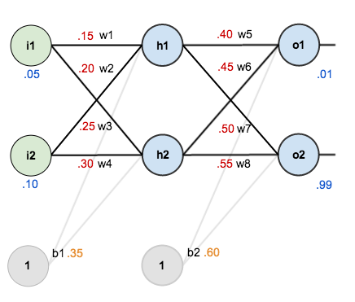
Fig 1: Neural Network

Transaction | Items
1 | {laptop, wireless mouse, keyboard}
2 | {laptop, Keyboard}
3 | {wireless mouse, bag}
4 | {laptop, wireless mouse}
5 | {keyboard, wireless mouse}
6 | {Laptop, bag}
7 | {laptop, wireless mouse, keyboard, bag}
Table 1: Apriori Algorithm

